Aryan Pathak
SAP ID: 590033176
Batch: 16
Experiment -1
- Setting up of the platform
We can do C programming online or offline according to the needs. It is required for us to keep working on a Linux Environment. Online: Cocalc.ai Offline:
Methods: Dual boot, Single boot, Bootable Pendrive, VM
- Virtual Machine Manager (Hypervisor)
Type-1 (Baremetal) What E.g.
Type-2 (Hosted) What
E.g Oracle Virtualbox, VM Ware.
We would be using Oracle Virtualbox.
- Installation of VMM & VM
Step-1: Download Oracle Virtual Box (paste the link, attach screenshot)
Step-2: Download Kali Linux VM (paste the link, attach screenshot)
Step-3: Extracted the Kali Linux downloaded file
Step-4: Install Virtualbox
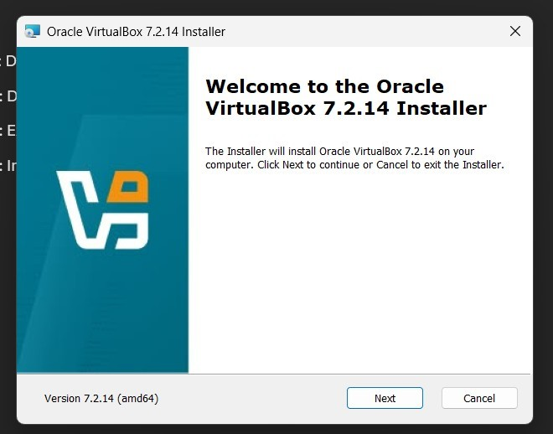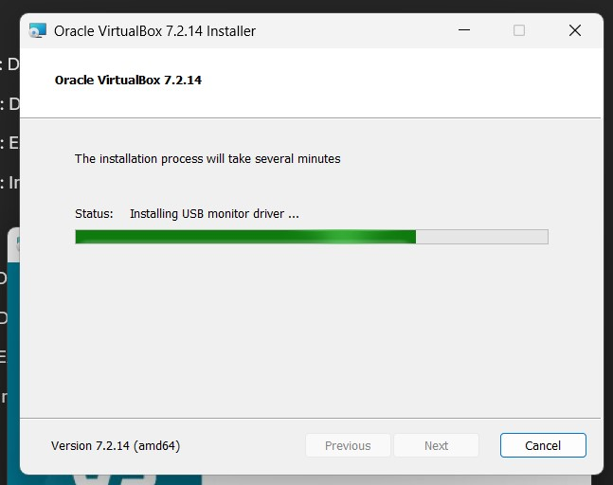
Step-5: Open Virtual box
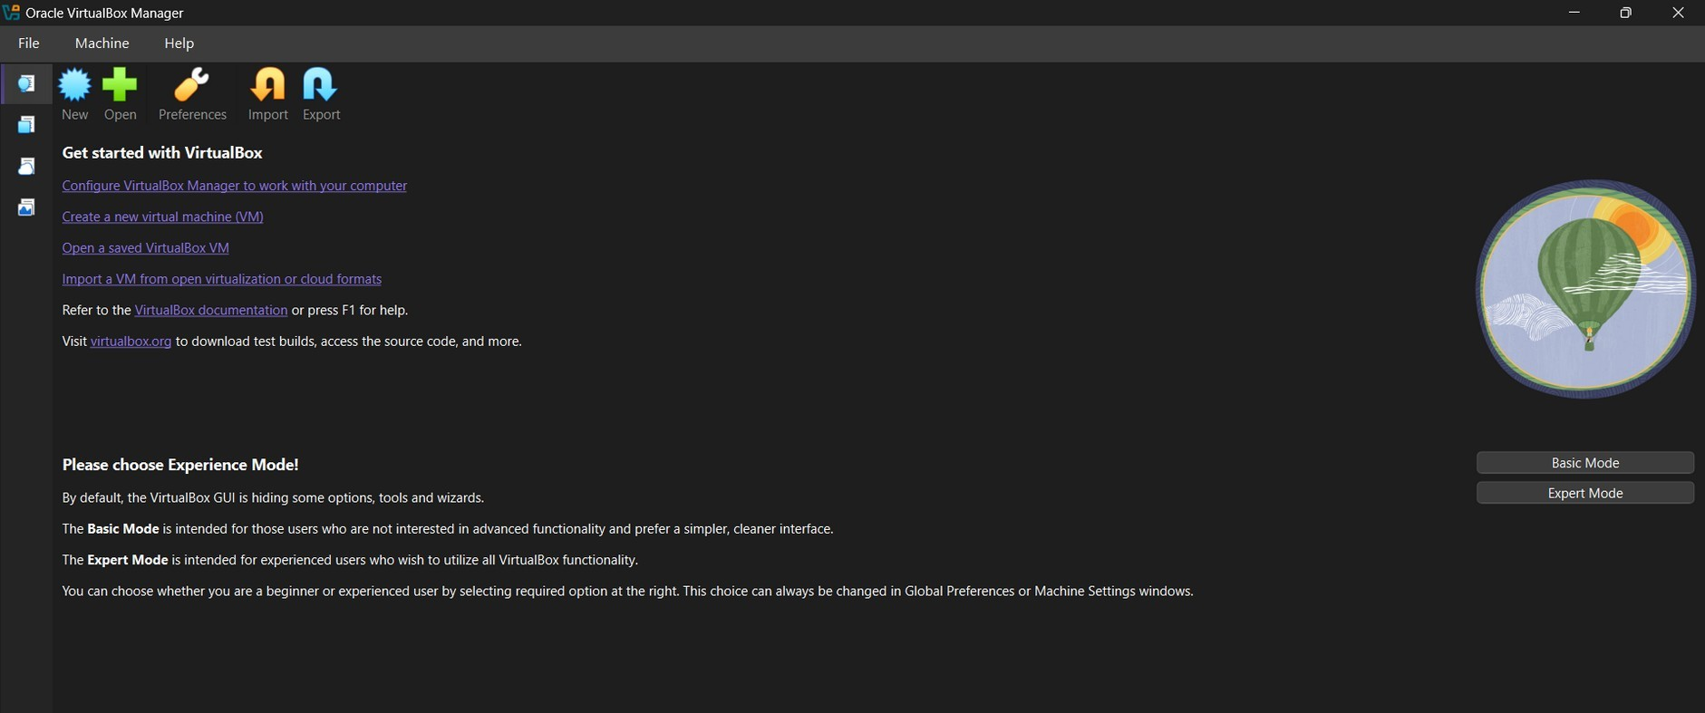
Step-6: Opening the saved VM
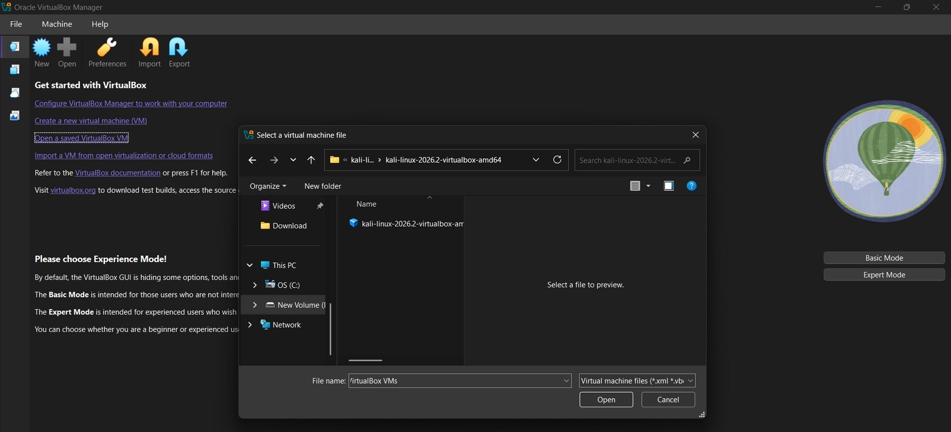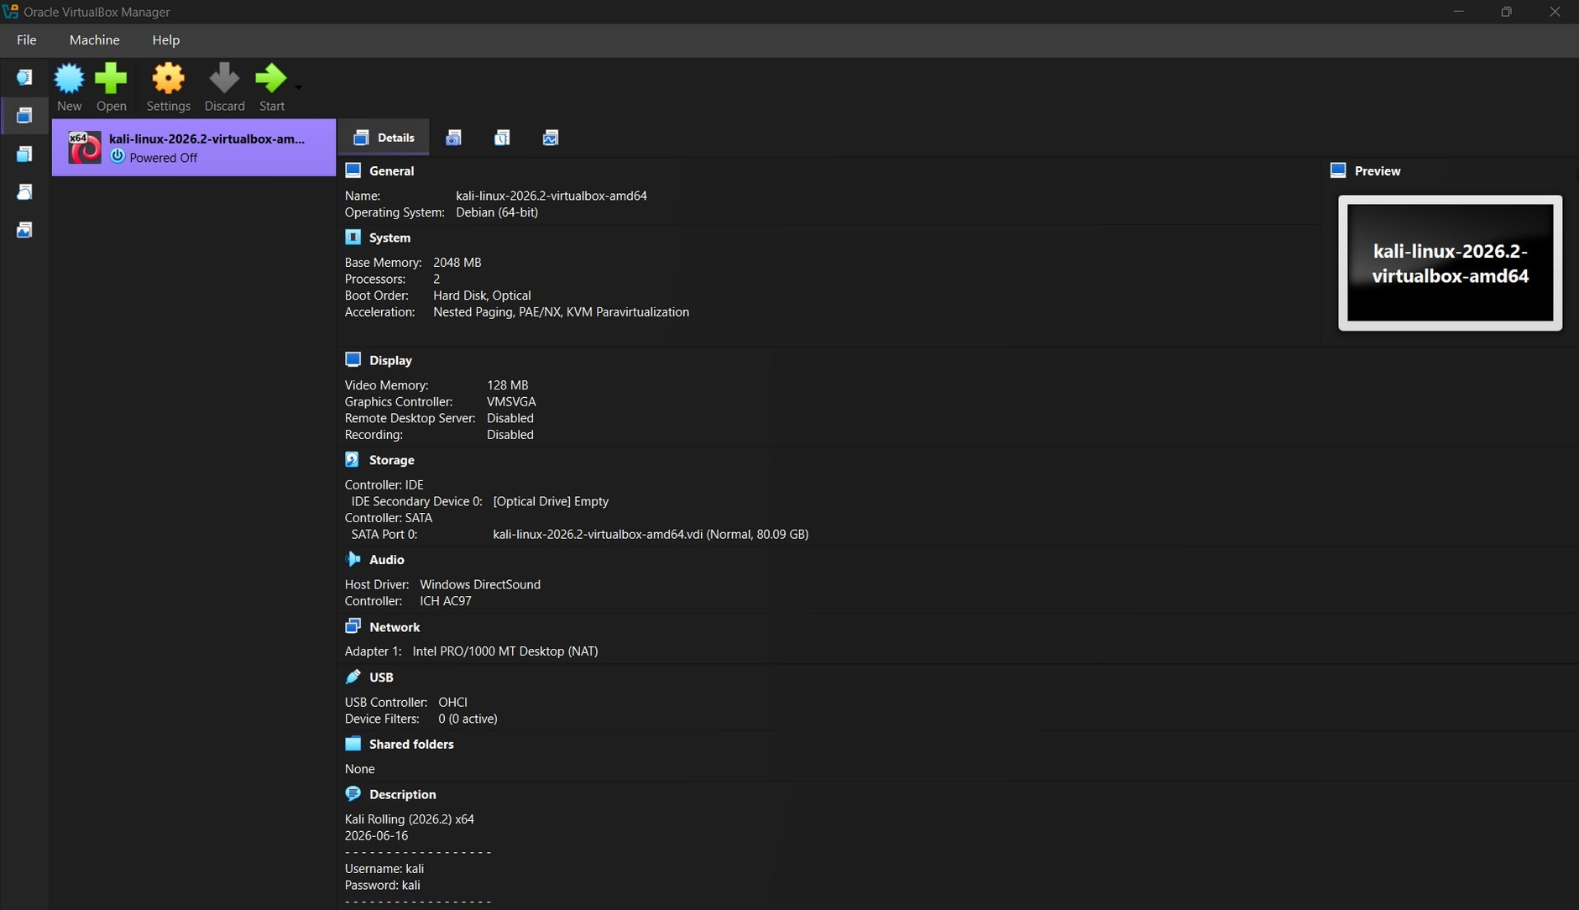
Step-7: Start the VM

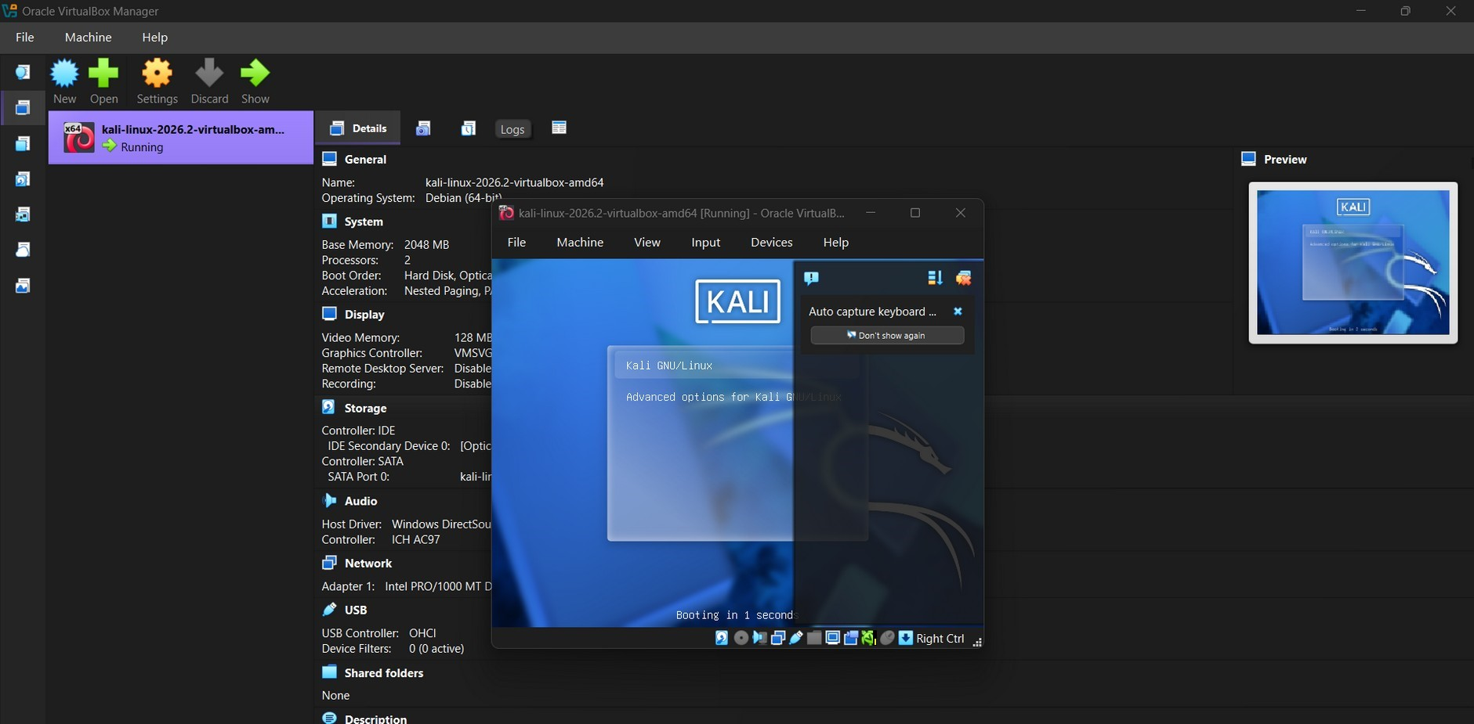

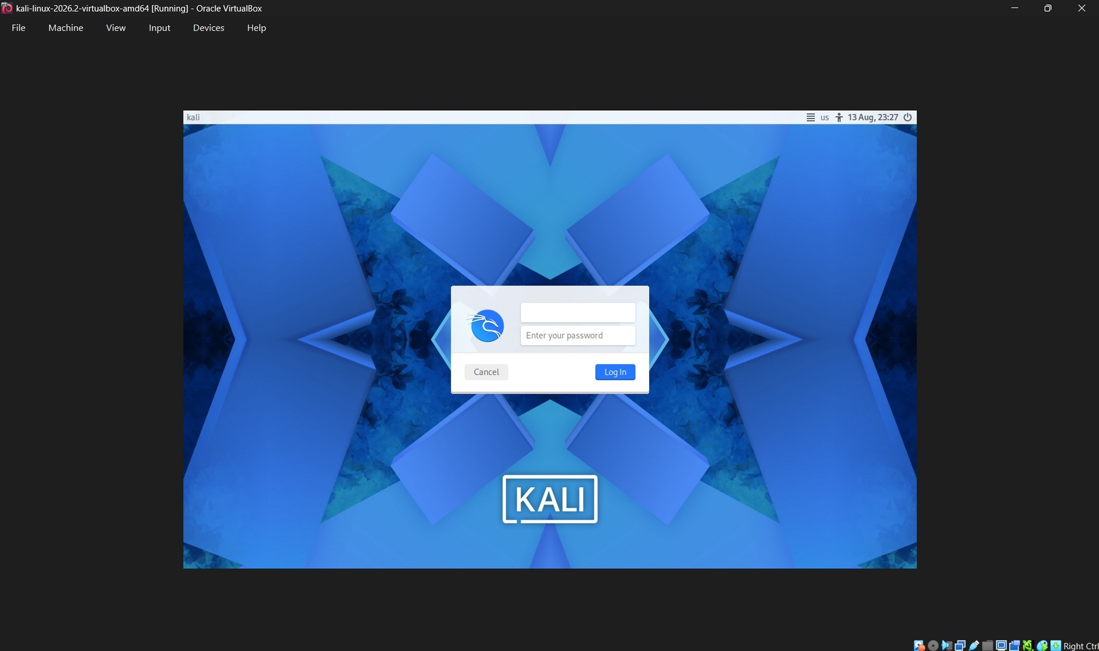
Thus the installation of VMM (Hypervisor Type-2 Oracle VirtualBox) & VM (Kali Linux) is completed.

